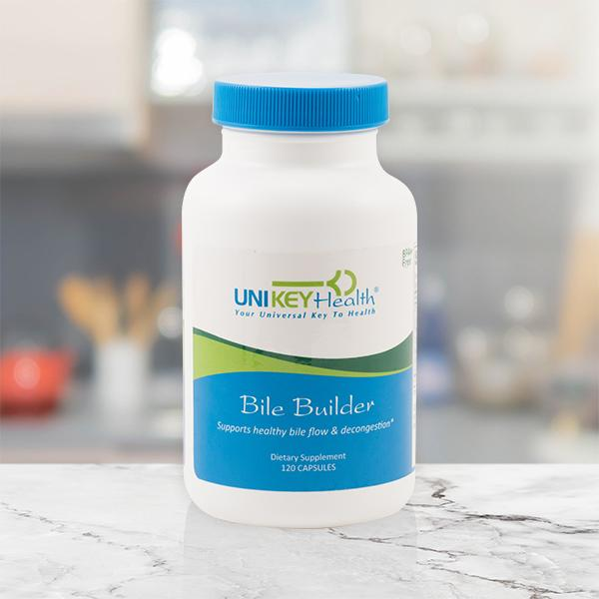
BILE BUILDER
Support adequate bile production and healthy bile flow...with or without a gallbladder! *
Build better bile with 6 key nutrients*
The six key nutrients in Bile Builder: choline, taurine, beet root, pancreatic lipase, ox bile and Collinsonia root come together for an optimum bile support supplement and work synergistically to help your body produce, thin out and move bile efficiently for optimum gallbladder and liver support! *
Bile Builder contains:
- Choline - assists with fat digestion. *
- Taurine - helps bile to excrete chemicals detoxed by the liver, promotes increased bile acid production and supports healthy cholesterol levels in the blood and liver. *
- Beet Root - contains betaine which helps promote thin, free-flowing bile. Betaine is also a rich source of hydrochloric acid which is helpful for digestion and helps trigger the release of bile from the gallbladder. *
- Pancreatic Lipase - helps break down fats as a digestive enzyme. *
- Ox Bile - provides important bile salts helpful for those with low bile production or without gallbladders. Bile deficiency is especially common for those over age 60. *
- Collinsonia Root (stone root) - an herb used traditionally for centuries to help with gallstones and avoid constipation resulting from bile salt supplementation. *
Gallbladder grief...gone?
Its critical role in digestion and detoxification is often overlooked, but bile is something you truly can't live without! Produced by your liver, this thick fluid is sent through tiny ducts to your gallbladder where its stored until it's needed. Its primary job is to breakdown fats into particles small enough for your digestive system to process. When there's fat to digest, the gallbladder contracts, sending bile into the small intestine where its work begins.
If you're one of the millions of adults without a gallbladder, your bile flow is no longer regulated. Without controlled release of bile, your body isn't able to absorb critical fat soluble vitamins or essential fatty acids. Over time, this can lead to a number of health concerns.
Signs of bile deficiency could include:
- Constipation*
- Low thyroid*
- Weight gain*
- Nausea*
- Bitter taste in mouth*
- Fatigue*
- Sciatica-like pain*
- Ringing sound in ears*
- Light colored stools*
- Sleeplessness*
- Sluggish digestion*
- Headaches*
The bile detox connection
Another important role that bile plays is in helping the liver flush out toxins. But, in order for this to happen, it has to be thin enough to flow efficiently through the bile ducts. The consistency of your bile is directly related to the quantity of toxins you can eliminate. Thick, congested bile can clog bile ducts and stop the detox process in its tracks. When toxins are stuck in your intestinal tract, they are reabsorbed, which can take a toll on organs and joints.

