BIOGENA Vitamin C 500 buffered GOLD
The stomach-friendly vitamin C complex**
Vitamin C - the classic immune-system support**
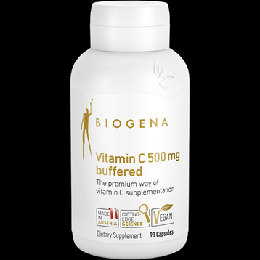
Vitamin C is primarily known for its effect on the immune system. However, vitamin C can do more than that and is involved in many other processes in the body. Through its role in collagen formation, the water-soluble vitamin supports the normal functioning of the blood vessels. Furthermore, it is important for our antioxidative defense system: It contributes to protecting the cells against oxidative stress and recycles used vitamin E.**
Vitamin C 500 buffered GOLD - premium class vitamin C
The best-known form of vitamin C is ascorbic acid. Due to its strongly acidic properties, it can irritate the sensitive mucous membranes in the stomach. Vitamin C 500 buffered GOLD, on the other hand, contains a stomach-friendly mixture of naturally occurring vitamin C metabolites, including the natural vitamin C companion “L-threonate”. This calcium ascorbate-L-threonate complex is well absorbed and stays in your system longer than regular vitamin C.**
Biogena Vitamin C 500 buffered GOLD – what is it?
Biogena Vitamin C 500 buffered GOLD is a blend of vitamin C and various flavonoid compounds to provide enhanced vitamin C support. It contains a natural vitamin C complex that is well absorbed and lasts longer than regular vitamin C. This non-acidic, stomach-friendly vitamin C complex is also recommended for sensitive individuals. **
Biogena Vitamin C 500 buffered GOLD
- Premium class vitamin C: easily absorbed, stomach-friendly, long-lasting immune support**
- Supports the immune and the antioxidant system**
- For skin, blood vessels and gums**
- Increases the uptake of iron**
- Helps reduce tiredness and fatigue**

