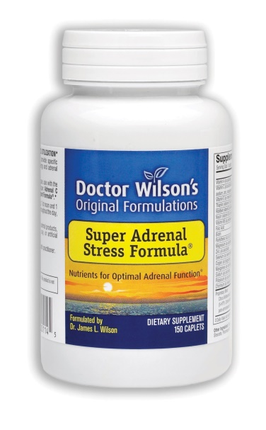
Dr Wilsons Adrenal Health Support without Stimulants
Dr. Wilson's Super Adrenal Stress Formula contains powerful nutrients that support balanced and healthy adrenal glands and ease the effects of stress while supporting energy levels without stimulants.
Natural Support for Stress Relief
Suitable for continuing use, this dairy and caffeine-free vegan supplement
- Utilizes optimal proportions of vitamins, minerals and nutrients to support stress relief
- Comes in a special time-release formula for optimal absorption
- Provides nutrients to support overworked adrenal glands
- May help maintain normal stress hormone production
Rich Source of B-Vitamins and 5-HTP
This specially designed nutrient complex contains
- B-vitamin complex - Your body uses B vitamins for many vital processes, including energy production, and generally requires more during periods of stress.
- 5-HTP- An amino acid that may help regulate stress-hormones and mood.
- Kelp - Sea vegetable that contains potassium, iodine, B vitamins and minerals that may provide powerful support for glandular health.
Nutrition Facts
Supplement Facts
1 caplet contains:
Vitamin A (as palmitate) 1,500 IU (32%)
Vitamin C 308mg (513%)
---(as ascorbic acid, magnesium, zinc, manganese and potassium ascorbates)
Vitamin E (as mixed tocopherols) 16 IU (53%)
Thiamin (vitamin B1 as thiamine HCl) 5mg (333%)
Riboflavin 5mg (294%)
---(vitamin B2 as riboflavin HCl and riboflavin-5'-phosphate)
Niacin (vitamin B3 as inositol hexaniacinate) 26mg (130%)
Vitamin B5 (as d-calcium pantothenate) 240mg (2400%)
Vitamin B6 30mg (1500%)
---(as pyridoxine HCl and pyridoxal 5'-phosphate)
Folate (as 5-formyl tetrahydrofolate) 200mcg (50%)
Biotin 200mcg (67%)
Pantothenic Acid (as d-calcium pantothenate) 240mg (2400%)
Magnesium (as ascorbate/citrate) 40mg (10%)
Zinc (as ascorbate) 3mg (20%)
Selenium (as selenomethionine) 100mcg (114%)
Copper (as glycinate chelate) 0.2mg (10%)
Manganese (as ascorbate) 2mg (100%)
Sodium (as ascorbate) 5mg (<1%)
Potassium (as ascorbate) 1mg (<1%)
Chromium (as trivalent chromium chloride) 200mcg (167%)
Proprietary Blend (180mg)
---Citrus bioflavonoids, inulin (from organically grown agave), para-aminobenzoic acid (PABA), L-5 hydroxytryptophan (5-HTP), kelp, choline bitartrate, alfalfa juice
Other Ingredients: stearic acid, dicalcium phosphate, cellulose, carbomer, magnesium stearate and aqueous clear glaze.
Recommended Use:
Adults: Take 1 to 6 caplets daily or as recommended by a healthcare professional.
Warning:
If you are pregnant or nursing, please consult your healthcare professional before using this product. Keep out of the reach of

