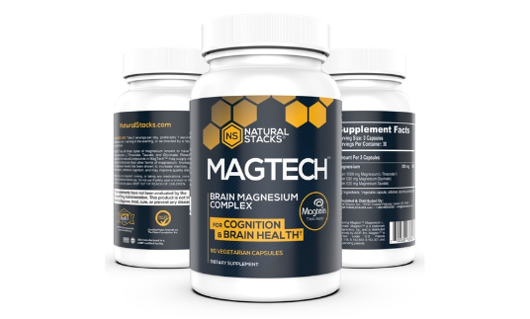
MagTech Magnesium Complex
How It Works
MagTech® is the highest quality magnesium complex on the planet featuring three types of magnesium known to have the highest absorption rates, each with unique biological effects: L-Threonate, Taurate, and Glycinate.
Research suggests that the magnesium-l-threonate in MagTech™ is the only form of magnesium proven to cross the blood-brain barrier and:
- Increase synapse density†
- Support healthy cognitive aging†
- Support healthy learning and memory†
- Promote relaxation and support quality sleep†
100% chelated and optimized with nutritionally functional amino acids, MagTech™ is the best magnesium complex on the market.
MagTech is an innovative magnesium supplement unlike any other on the market. By including magnesium glycinate and magnesium taurate, MagTech combines the calming, sleep-promoting powers of traditional magnesium supplements and adds the breakthrough technology of the super mineral magnesium-l-threonate to elevate brain concentrations of magnesium.
This combination is something no other form of magnesium can do.
Think Clearly & Sleep Better with MagTechMagnesium-l-threonate
Magtein™ (the trademarked name of magnesium l-threonate in MagTech) has been shown to significantly increase the brain’s number of synaptic connections / synaptic density (see graph on the left) and enhance both short-term and long-term memory (see graph on the right).
This MIT study concluded: “Our findings suggest that an increase in brain magnesium enhances both short-term synaptic facilitation and long-term potentiation and improves learning and memory functions”.
The same double-blind, placebo-controlled human clinical trial researchers found that with MMFS-01 (magnesium-l-threonate) treatment "overall cognition improved significantly at week 6 and maintained improvement at week 12". They also concluded that it improved 'brain age' by 9 years based on "restored impaired executive function of the subjects" (age 50-70). [5]
Top neuroscientists from universities in Beijing, Texas, and Toronto found that “elevation of brain magnesium, by a novel magnesium compound [magnesium-l-threonate (MgT)], enhances synaptic plasticity in the hippocampus and learning and memory” [6]
Twelve scientists at MIT conducted a study on magnesium-L-threonate and concluded that “an increase in brain magnesium enhances both short-term synaptic facilitation and long-term potentiation and improves learning and memory functions.” [7]
A study using magnesium-L-threonate discovered that “Elevation of Brain Magnesium Prevents and Reverses Cognitive Deficits and Synaptic Loss” [8]
Magnesium Glycinate
Magnesium glycinate is a highly bioavailable form of magnesium and a significant source of glycine, an amino acid that promotes deep sleep and the elimination of toxins from the body.
Glycine (found in Magnesium Glycinate):
A 2012 study on healthy male volunteers found that "glycine improves daytime sleepiness and fatigue induced by acute sleep restriction" [9]
A study on individuals with continuous complaints about the quality of their sleep concluded that "glycine ingestion significantly improved the following elements: 'fatigue', 'liveliness and preppiness', and 'clear-headedness'." [10]
When studying the effects of glycine ingestion before bedtime on volunteers who have been experiencing unsatisfactory sleep, scientists in Japan found that it "improved the volunteers' satisfaction with their sleep, the difficulty of sleep onset, and sleep efficiency" [11]
Glycine concentrations in the brain have also been shown to positively “influence learning and memory functions” in both young and old adults by facilitating memory retrieval. [12]
Magnesium Taurate
Magnesium taurate delivers an important amino acid, taurine to the brain and body. Magnesium and taurine have synergistic and potentiating roles.
Magnesium and taurine work together to stabilize cell membranes throughout the central nervous system and maintain neurotransmitter balance. One of taurine’s main tasks is to facilitate the passage of sodium, potassium, and magnesium ions into and out of cells for optimal neuronal activity.
Taurine is an amino acid that acts as an antioxidants and has a role in vision, cardiac health, bile production, as well as muscle growth.
Taurate (found in Magnesium Taurate)
Researchers at Tufts University found that "Taurine increased choice reaction time" and "Taurine reversed the effects of caffeine-withdrawal symptoms" [13]
A recent study on taurine's ability to support healthy cognition through the aging process concluded that taurine supplementation "significantly ameliorated the age-dependent decline in spatial memory acquisition and retention" and can "forestall the age-related decline in cognitive functions". [14]
In Japan, a study of 25 male college students found that "taurine supplementation alleviates visual fatigue induced by visual display terminal (VDT) work" [15]

